Electrical instructions

1. Electrical assembly platform

**Timing:** 1h

**Materials:** Aluminium plate, electrical components (power supplies, controller boards, din rail components, cable drag chain).

**Equipment:** Screws, nuts and spacers (M3, M4 and M5), M3 male nylon spacers and nuts, Allen keys.

**Critical:** Make sure that mechanical components don’t touch any electrical circuit (especially when assembling small electronic devices).

Aluminium plate of dimensions 770x290x3mm was used as a base to assemble most of the electrical components of the MEW platform. **Figure 1** shows the location of the electrical components on the Aluminium plate where each device was numbered for simplicity of the assembly instructions.

1. Use M3 screws to mount 12VDC (1), 48VDC (2) and 24/5 VDC (3).
2. Use M4 screws to mount din rail (4).
3. Use M3 Nylon spacers to mount Smoothieboard (5) and create a gap between the device and Aluminium plate.
4. Use M3 screws to mount Arduino Due (6) using provided plastic base plate.
5. Attach mini breadboard (7) using adhesive.
6. Mount two thermocouple amplifiers (8, 9) and two digital-analog converters (10, 11).
7. Prepare attachment point for five cable drag chains (12-16).

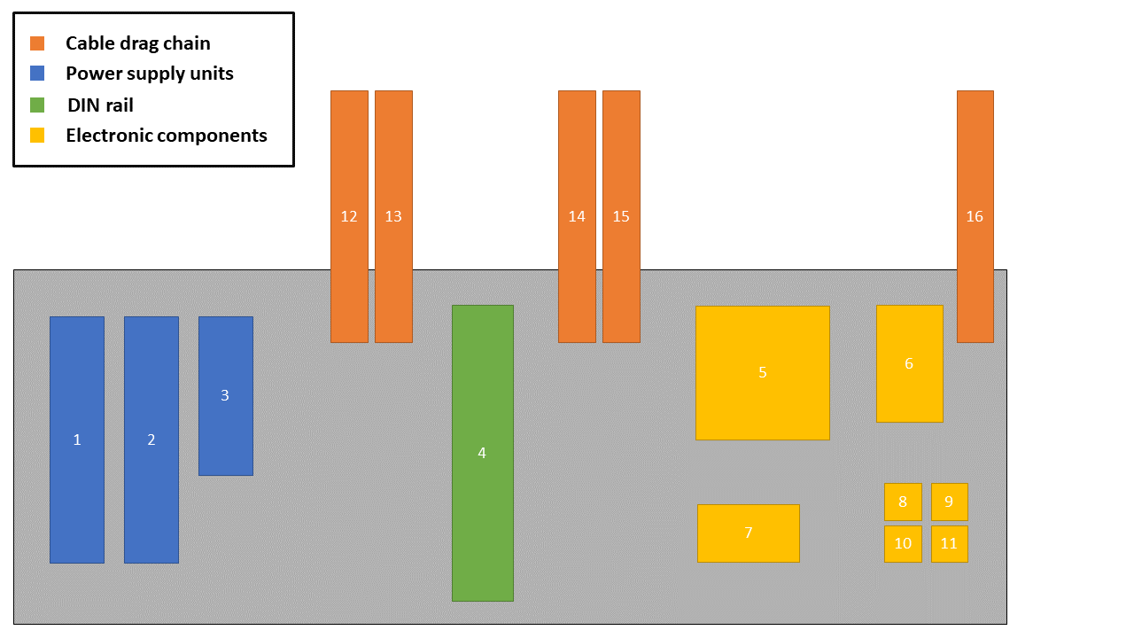

Figure 1. Distribution of electrical components across the Aluminium assembly plate. There are 3 power supplies (blue), 1 din rail (green), 7 electronic components (yellow) and 5 cable drag chains (orange).

1. Cable drag chain

**Timing:** 0.5h

**Materials:** As listed in the kit documentation.

**Equipment:** M4, M5 Allen key.

**Critical:** Test whether the length of each drag chain is sufficient to allow the drawer to slide out.

Cable drag chain was used to provide a neat and convenient way of guiding electrical connections to sensors and actuators. Since the electrical components were mounted on a withdrawable Aluminium plate, a cable drag chain provided a great solution to maintain secure and safe connection even for moving components.

The instructions how to assemble cable drag chain are available online 1,2

Figure X shows a final cable drag chain assembly used the to guide cable connecting sensors and actuators. One end of each chain is attached to the Aluminium base plate (X) while the other end is attached to the 30x30 Aluminium profiles (X) using L-shaped brackets.

Here show a photo of the chain and it is attached to the Aluminium profile.

1<https://www.youtube.com/watch?t=1618&ref=0dnte9dlczx&v=6LY1KcPJ4s4&feature=youtu.be&ab_channel=OpenBuilds>

2<http://makerhardware.net/wiki/doku.php?id=add_on_packs:cable_drag_chain_mounting_pack>

1. Smoothieboard

ADD TTL-USB

**Timing:** 1h

**Materials:** XG and 4-core XG cables, thermocouple, thermocouple extension cable, thermocouple female connector, thermocouple amplifier, XT60 connectors, stepper motors, phoenix connectors (supplied with Smoothieboard), USB type A (male) to USB type B (male) cable.

**Equipment:** Wire strippers, wire crimping tool.

**Critical:** Make sure all connections are correctly wired before turning the power on.

Smoothieboard connection diagram is shown in Figure 2. Refer to this figure during wiring process.

1. Connect x-axis stepper motor to smoothieboard. Connect ENA+, DIR+ and PUL+ motor pins to EN1, DIR2, ST1 on smoothieboard. GND is connected to ENA-, DIR- and PUL-
2. Repeat step 1) for y-axis and z-axis stepper motor using EN2, DIR2, ST2, EN3, DIR3, ST3. For detailed motor documentation refer to the stepper motor datasheet3.
3. Connect thermocouple amplifiers4.
4. Use thermocouple extension cable and female thermocouple connector to connect both syringe and ring thermocouples to the corresponding amplifiers.
5. Connect ring and syringe heaters using XT60 and phoenix connectors.
6. Connect 12VDC.
7. Connect Smoothieboard to the PC via panel mount USB connector.

3 <https://www.omc-stepperonline.com/download/ISS23-10.pdf>

4 <https://www.adafruit.com/product/1778>



Figure . Simplified Smoothieboard circuit diagram. Three stepper motors, thermocouples, thermocouple amplifiers, nozzle and syringe heaters are connected to Smoothieboard. Computing unit is connected to via USB while the 12VDC power supply provides power to the microcontroller board.

1. Arduino

ADD TTL-USB

**Timing:** 2h

**Materials:** Jumper cables, USB A to USB micro cable, XG and XG 4-core cable, pressure regulator with a connecting cable, pressure sensor with a connecting cable, solder, resistors, operational amplifiers, capacitors, pin headers.

**Equipment:** Wire strippers, wire crimping tool, soldering iron, tweezers.

**Critical:**

A custom Arduino PCB shield has been designed to allow several sensors and actuators to exchange data. PCB layout and circuit schematic are available in attached documentation5. Figure 3 shows a simplified circuit diagram.

Note: The PCB design includes components that are not used in the presented version of MEW platform and can be considered as a future improvement.



Figure . Simplified Arduino Due + PCB shield circuit diagram. Pressure sensor, pressure regulator, high voltage unit, digital-analog converters are connected to Arduino Due via PCB shield.

*5 Link to GitHub repository with documentation*

*PCB*

1. Solder components (R1-3, U1-6, C1-7) as described in the circuit schematic.
2. Solder header pins to POWER, AD_L, DIGITAL, COMMS, PWM_L as shown in.
3. Connect PCB shield to Arduino Due.

Figure X. Complete Arduino shield PCB.

*Digital-analog converter*

Refer to Figure 3 and online tutorial6 for wiring instructions of MCP4725 digital-analog converter.

*Pressure sensor*

Using provided Schmalz connection cable, connect:

1. Pin 1(Brown) to 24VDC via din terminal.
2. Pin 3(Blue) to GND via din terminal.
3. Pin 4(Black) to P3 on PCB.

Next:

1. Connect P2 to AD0 on PCB.

*Pressure regulator*

Using provided SMC connection cable, connect:

1. Pin 1(Brown) to 24VDC
2. Pin 2(White) to Pin 21 on PCB.
3. Pin 3(Blue) to GND.

Next:

1. Connect P19 to pin VOUT on DAC #1

*High voltage*

Using 4-core and earth cable, connect:

1. Pin 1 (earth) to the chassis of the platform.
2. Pin 3 to Pin 11 on PCB.
3. Pin 4 to GND on din terminal.
4. Pin 5 to 24VDC.
5. Pin VM (voltage monitor) to pin AD1.
6. Pin CM (current monitor) to pin AD2.

*USB connection*

1. Connect Arduino to the PC via a panel mount USB connector.

6 <https://learn.adafruit.com/mcp4725-12-bit-dac-tutorial/wiring>

1. Din terminals

**Timing:** 1h

**Materials:** Aluminium din guide rail, din terminals, relay holder, relay.

**Equipment:** M5 Allen key, flat head screwdriver.

**Critical:** Make sure din screw terminals are not shorted with each other (one side of a din screw terminal is exposed and the other one is not).

Figure X shows complete din terminal assembly.

1. Mount Aluminium din guide rail.
2. Mount grey din terminals (optional: use separator plate between different voltage levels).
3. Use jumpers to distribute the power between terminal blocks (see Figure X).
4. Mount earth terminals (green/yellow) and lock them in.
5. Mount a relay holder.
6. Place a relay insider a relay holder.
7. Power

**Timing:** 1h

**Materials:** Power supply units, IEC wall mount connector, mains cable, fork and female spade crimp terminals.

**Equipment:** Crimping tool

**Critical:** Power system was designed according to Australian standards. Please check and adjust accordingly for other countries.

Power system consists of 3 power supplies: 320W 48VDC, 350W 12VDC, 68W dual output 5 VDC and 24VDC. IEC panel mount connector with a 10A fuse and illuminated switch is used to provide mains power to the platform.

**IMPORTANT:** Power system must be checked by a certified electrician. It is **NOT** recommended to perform wiring of mains power as well as any of the power devices by an unauthorised person.

Once the mains power is connected, make sure the power is switched **OFF**. Figure X shows how low-level voltage (<50VDC) is distributed between din terminals.

1. Connect positive and negative output of 48VDC.
2. Use terminal jumpers to distribute accordingly.
3. Connect positive and negative output of 24VDC.
4. Use terminal jumpers to distribute accordingly.
5. Connect positive and negative output of 12VDC.
6. Use terminal jumpers to distribute accordingly.

Follow a circuit schematic in Figure X to connect input power to other electrical devices.

1. Connect 12VDC to smoothieboard
2. Connect 24VDC to the pressure regulator.
3. Connect 24VDC to the pressure sensor.
4. Connect 48VDC to the linear actuators.
5. Safety

**Timing:** 1h

**Materials:** Non-contact magnetic switch,

**Equipment:** wire strippers

**Critical:** Make sure magnetic switches correctly toggle the electromagnetic relay on and off before connecting high voltage unit.

Non-contact magnetic switches are used along with the relays to make sure the high voltage is disconnected when any doors of the platform are open. This minimises the risk of a user getting shocked by the high voltage.

1. Connect magnetic switch#1 Pin 1(Brown) to 24VDC.
2. Connect magnetic switch#1 Pin X(Blue) to GND.
3. Connect magnetic switch#1 Pin X(Gray) to 24VDC.
4. Connect magnetic switch#1 Pin X(Black) to magnetic switch#2 Pin X(Gray).
5. Connect magnetic switch#2 Pin X(Black) to relay input.
6. Connect relay output to GND.
7. Connect a diode1N4004 between magnetic switch#1 Pin 1(Brown) and Pin X(Black)
8. Connect a diode1N4004 between magnetic switch#2 Pin 1(Brown) and Pin X(Black)
9. Monitoring and illumination

**Timing:** 1h

**Materials:** USB3 cable, lens, camera, LED panel, 12VDC power supply, solder, XG cable, M5 screws and hammer nuts

**Equipment:** Soldering iron, M5 Allen key

**Critical**: Consider heat radiating from the LED at high current operation.

Basler Ace camera connects with a computing PC via USB3 cable. USB port also supplies power to the camera; therefore this is the only connection needed.

A 20x40mm LED panel was mounted on a 20x20 profile and powered with external power source as shown in Figure X.

1. Final